May 15th, 2011
Hi
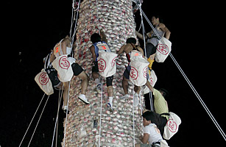
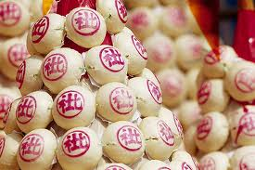
Tuesday was a holiday, for the Buddha's birthday. It was also the day of the annual bun scramble up the towers on Cheung Chau at midnight. The picture shows some of the buns. The buns used on the towers today are actually made of plastic. The buns are numbered, with those at the top of the tower having higher numbers. The winner of the scramble is the one to get the highest score from the buns collected in the time allowed. There was a shortage of (real) buns for sale this year as the Health Department decreed that the stamping of buns with the red chop, which is carried out in the open for the public to view, is unhygienic and so was banned, in spite of the fact that it has been carried out this way for many years with no apparent ill effects. As a result, one of the two major bakeries refused to make the buns. The characters on the chop mean “peace and (?)health”.
On Thursday, I went for my dermatology appointment. Again there was a new person, which is rather annoying as they are not familiar with the case and so I have to go through everything again! Nothing suspicious. The next appointment is not for six months.
Three more swims this past week, 1.5 km each time. As I have mentioned, I am trying, with some success, to change my arm style.
Yesterday when I turned on my computer it began misbehaving: keyboard lights flashing, boxes opening by themselves. I played around with the settings without really knowing what I was doing. It seemed to correct itself after several hours.
Today – your time - is Gavin's birthday. I hope you all remembered it.
That seems to be it for now.
Cheers
PS: There is an interesting article in the latest Time magazine related to what we were commenting on in our e-mails regarding execution versus a trial. The article refers back to what happened with Che Guevara:
http://www.time.com/time/magazine/article/0,9171,2071019,00.html

